SHOULD I STAY OR SHOULD I GO

Darling you’ve got to let me know
Should I stay or should I go?
If you say that you are mine
I'll be here ‘til the end of time
So you’ve got to let know
Should I stay or should I go?.
Always tease tease tease

You're happy when I'm on my knees
 
One day is fine, next is black
 
So if you want me off your back

Well come on and let me know
Should I stay or should I go?.
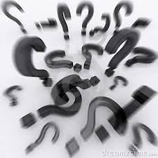
Should I stay or should I go now?
Should I stay or should I go now?
If you go, there will be trouble
And if you stay, you will be double
So come on and let me know.
This indecision’s bugging me
If you don't want you, set me free

Exactly who am I supposed to be
Don't you know which clothes even fit me?
Come on and let me know.

Should I cool it or should I blow?
Should I stay or should I go now?
If I go there will be trouble

And if you stay I will be double
So you’ve got to let me know
Should I stay or should I go?.

